--1.

CREATE OR REPLACE PROCEDURE insert_glaccount

(

client_Account_number number,

client_Account_description in varchar2

)

AS

BEGIN

insert into general_ledger_accounts values(client_Accout_number , client_Account_description);

COMMIT;

END;

/

call insert_glaccount (900,'novel account dsa');

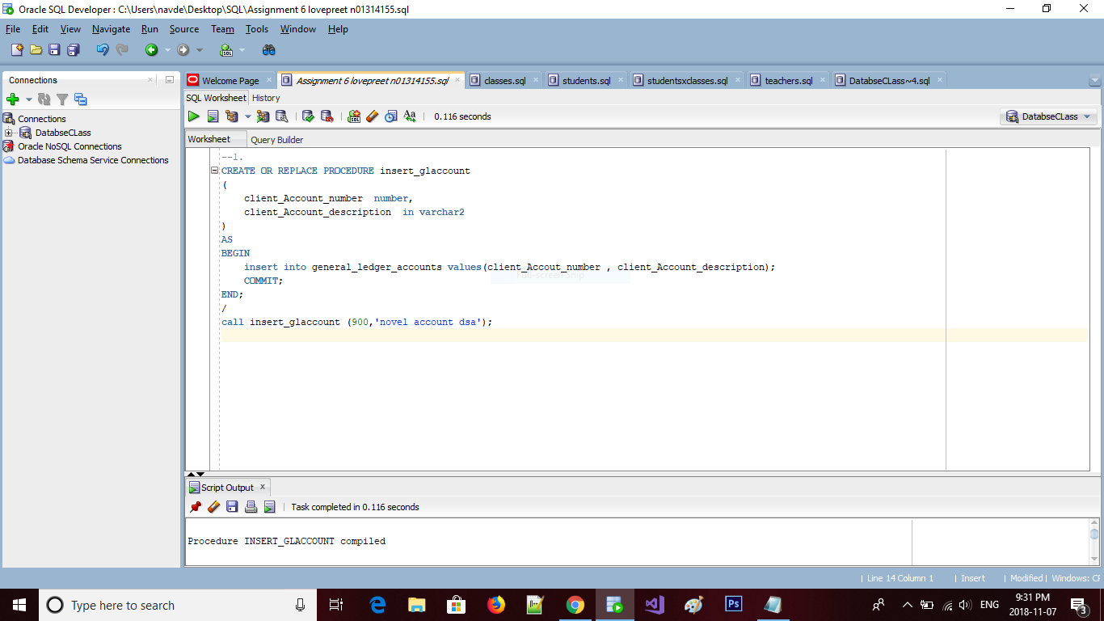

--2

set serveroutput on

begin

insert_glaccount(900,'novel account dsa');

insert_glaccount(901,'novel account dsb');

commit;

exception

then dbms_output.put_line ('a dup_val_on_index error ocurred');

rollback;

when

others

then dbms_output.put_line('an unknown exception occured');

rollback;

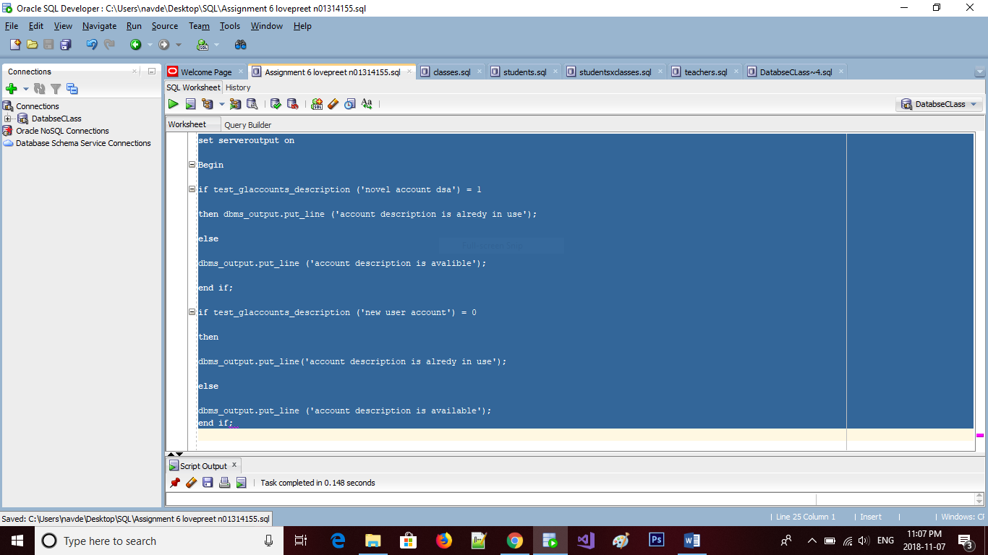

end;

3.

CREATE OR REPLACE function test_glaccount_description

(

client_Account_description varchar2

)return number

is

general syntax

general_ledger_accounts.account_number%TYPE;

begin

select account_number

into general_syntax

from general_ledger_accounts

where

account_description = client_account_description

if SQL%ROWCOUNT = 1

then

return 1;

end if;

exception

where no_data_found

then

return 0;

end;



4

set serveroutput on

Begin

if test_glaccounts_description ('novel account dsa') = 1

then dbms_output.put_line ('account description is alredy in use');

else

dbms_output.put_line ('account description is avalible');

end if;

if test_glaccounts_description ('new user account') = 0

then

dbms_output.put_line('account description is alredy in use');

else

dbms_output.put_line ('account description is available');

end if;

